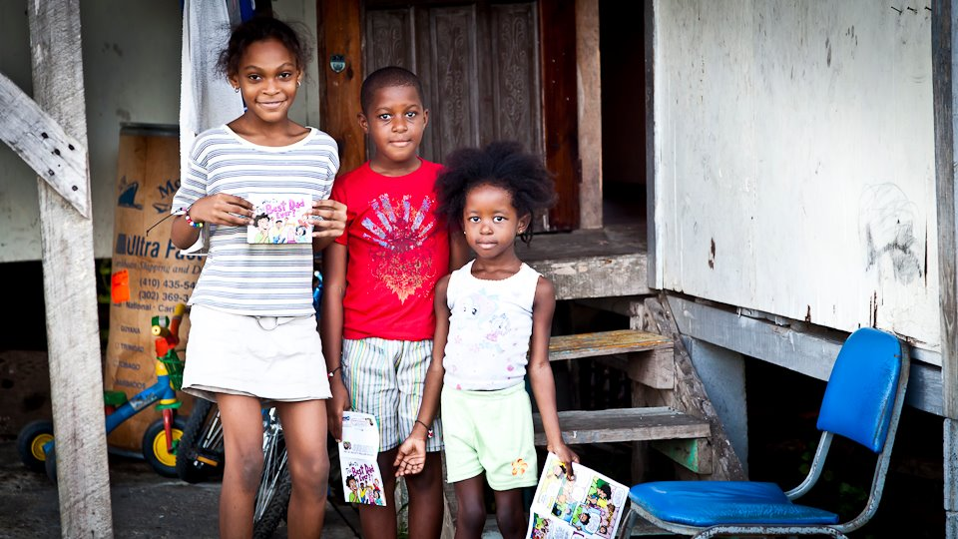
Dear Family! Since I got home this past summer from Birmingham Alabama with my sister Hosanna, God has been revealing his perfect love to me. Along with that revelation I have come to ponder deeply on how abundantly blessed we are. Thank you for all the ways you have blessed us both. Thank you for the wisdom, the patience, the discipline, and the time you have invested in us. Thank you for all the times you have lifted us up in prayer and spent your precious dollars to send us all over to experience the heart of God for his people. Whether it was to Mexico, Germany, or Alabama you always blessed us so much. Over the summer we got the opportunity to go to the precious neighborhood of Woodlawn Alabama. Statistically speaking Woodlawn is the most violent and dangerous neighborhood in all of Alabama, yet I see the love of Jesus seeping into every home and heart. Hosanna and I had an amazing time praying and talking to people there. Our team of teenage missionaries is now a family and they bring us so much joy. Thank you for making that trip possible with your love, prayers, and donations. This time we are headed to the island of Trinidad and Tobago. We will be gone from March 24-31st. The team will be partnering with “Every Home for Christ” to evangelize, by going to homes and market places telling people about Jesus and providing them with Christian literature. 150 students will be on the team, ultimately preaching the gospel of love to 15,000 people. While we are there we will also be developing a 24 hour prayer room. The trip will cost approximately $1500 each, depending on airfare. Our first payment deadline is December 14th, requiring $230 each. We are super excited about this trip and all that God has in store. Our desires for this trip are that God will expand our hearts and to learn more about evangelism. We want to learn more about mercy, and think of ourselves less. We desire deeply to know the heart of God for his people. We would like to ask you, once again, to be a part of this journey. We need prayer warriors, to pray for safety, revelation, wisdom, and that God will provide us with the finances. Without prayer we can do nothing. We will feel so loved if you would remember us and our team when you pray. We are also asking for donations towards our trip. If you would like to support our finances just make the check out to “New Life Church” and in the memo line write “Elizabeth & Hosanna Ramsdell-Trinidad&Tobago,” and send it in the mail to the address in the header. Thank you for all you are in both of our lives, and thank you for your support. May God bless you and give you victory and beauty everywhere you go.
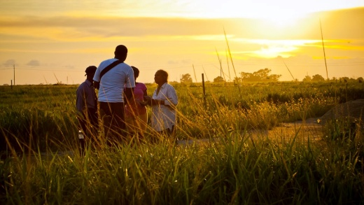
With Love,
Elizabeth and Hosanna
Ramsdell
We will be handing out Christian literature and talking about Jesus with people in the streets.
“What I whisper in your ear, proclaim from the rooftops”+Matthew 10:27

